XXXXXXXXXXXXXXXXXXXXXXXXXXXXXXXXXXXXXXXXXXXXXXXXXXXXX

XXX Aluna: Gina Szajnbok Harari

XXX TIA: 72008075 - CURSO MESTRADO EM CIÊNCIAS DA COMPUTAÇÃO

XXX Universidade Presbiteriana Mackenzie

XXXXXXXXXXXXXXXXXXXXXXXXXXXXXXXXXXXXXXXXXXXXXXXXXXXXX

**Tarefas da Semana**

**De 11/06 a 18/06**

**- Planejamento da metodologia para a elaboração da Ontologia**

**- Utilização do Prótegé**

**De 19/06 a 25/06**

**- Execução da formatação dos textos de apoio.**

**Tarefas dos Dias**

**De 26/06 a 28/06**

**- Inclusão de Data Proprieties e Execução da formatação dos textos de apoio. Testes com o Software FAR – Find and Replace.**

**Planejamento da metodologia para a elaboração da Ontologia**

1. **Motivação Histórica.**

Selecionar e verificar a existência de Ontologistas ao longo da história.<Ontologistas.docx> Ex. Spinoza, Russel.

1. **Seleção do texto básico sobre COVID-19para produzir os Objetos, Classes, e Propriedades da Ontologia:**

BMJ best Practice COVID-19. **BMJ Publishing Group Ltd. 2020**, London. Disponível em:

<https://bestpractice.bmj.com/topics/en-gb/3000168/pdf/3000168/Coronavirus%20disease%202019%20%28COVID-19%29.pdf>. Acesso em: 17 de jun. de 2020.

Resultado:

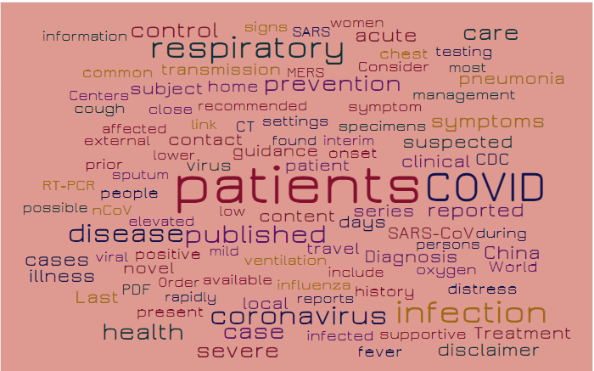

Possible patients guidance content published found patient interim travel ventilation days settings recommended low virus contact include influenza prevention onset specimens symptom local home transmission available respiratory clinical series mild coronavirus SARS-CoV link case infected positive Diagnosis disease history Consider COVID suspected severe Order SARS elevated sputum chest rapidly people lower acute close oxygen management symptoms control reported external MERS present infection health distress novel viral support ive women affected signs CT subject CDC prior during cough nCoV pneumonia most testing PDF care China common fever Centers reports persons disclaimer cases World illness Last Treatment RT-PCR information

1. **Seleção de textos de apoio1.**

Os textos de apoio serão retirados das seguintes fontes:

1. Referências bibliográficas da apresentação do Pré-Projeto da Dissertação da Disciplina de Metodologia de Trabalho Científico. (O Pré-Projeto possui 123 referências, o que tornou inviável para esta entrega. Na apresentação do Pré-Projeto foram selecionados os textos mais atuais e relevantes). <Apresentação_projeto_V14.pdf>, quais sejam:

--------

1. Observação importante: Percebeu-se, após alguns testes nas seleções de textos, que alguns deles, embora científicos, não serviram como base, mas tão somente como texto de apoio, pois o objetivo do texto não era conceitual e sim procedural, com execuções e resultados.

**- Trabalhos seminais em epidemiologia**

KERMACK, W. O.; MCKENDRICK, A. G. A contribution to the mathematical theory of epidemics. Proceedings of the Royal Society of London. Series A, Containing papers of a mathematical and physical character, The Royal Society London, v. 115, n. 772, p.700–721, 1927.

Resultado:

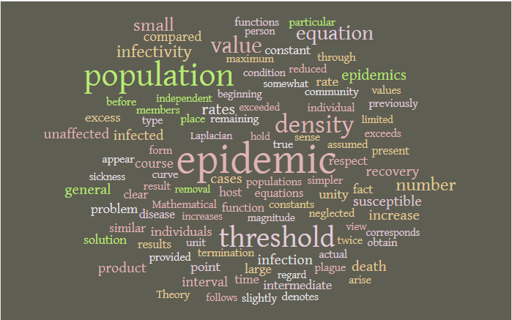

Epidemic population threshold density value equation numbers mall infectivity rates epidemics recovery infected product cases susceptible infection unaffected increase death general course interval compared rate unity individuals point excess problem host similar time fact constant solution larger espect intermediate function results disease equations present clear values reduced result individual true neglected appear particular curves members denotes unit actual previously populations community through before slightly obtain provided constants remaining place maximum assumed simpler exceeds termination twice plague form arise Theory functions Mathematical obtained whether lead identical consider used raw sickness difficulty independent regard discussion complete obtaining previous contact chance

**- Trabalhos recentes em epidemiologia, Sistemas Dinâmicos, *OSN (Online Social Network),* Teoria dos Jogos (Revisão Sistemática), Base de Dados**

CHANG, Sheryl L. et al. Game theoretic modelling of infectious disease dynamics and intervention methods: a review. Journal of Biological Dynamics, v. 14, n. 1, p. 57-89, 2020

Resultado:

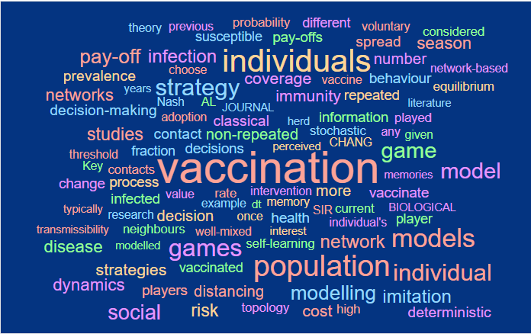

Theory vaccination perceived non-repeated intervention memory classical example health JOURNAL interest decisions self-learning once more herd immunity coverage rate population stochastic well-mixed strategy information SIR decision games contact adoption current individuals CHANG vaccinated fraction network individual's distancing susceptible repeated vaccinate infection modelling value process pay-offs game BIOLOGICAL Nash neighbours vaccine studies topology AL any contacts modelled models individual infected memories given risk probability years different high players behaviour played number previous social decision-making literature spread research change pay-off strategies voluntary dynamics choose transmissibility imitation prevalence equilibrium model dt cost Key network-based networks threshold player deterministic

FAN, D. et al. Novel fake news spreading model with similarity on PSO - based networks. Physica A: Statistical Mechanics and its Applications, Elsevier, p. 124319, 2020.

Resultado:

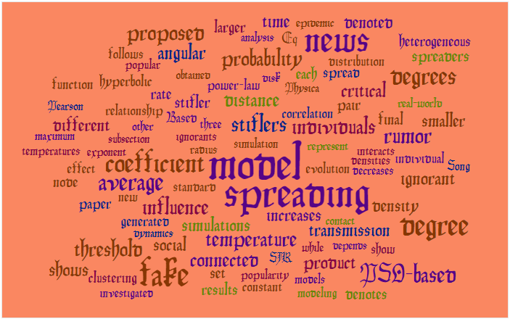

Model simulation spreading stiflers radius distances imulations ignorants three standard individuals represent temperature evolution increases power-law coefficient influence Based correlation stifler obtained transmission disk Physica probability connected while social pair product popularity news analysis each critical fake generated spread relationship average sub section rate angular larger densities other depends interacts proposed models final dynamics constant decreases hyperbolic set density distribution modeling individual popular ignorant clustering threshold degrees new rumor Eq denoted PSO-based contact results time papers how exponent spreaders smaller effect investigated denotes follows different degree Song function shows epidemic real-world node SIR temperatures maximum Pearson heterogeneous

MISTRY, Dina et al. Inferring high-resolution human mixing patterns for disease modeling. arXiv preprint arXiv:2003.01214, 2020.

Resultado:

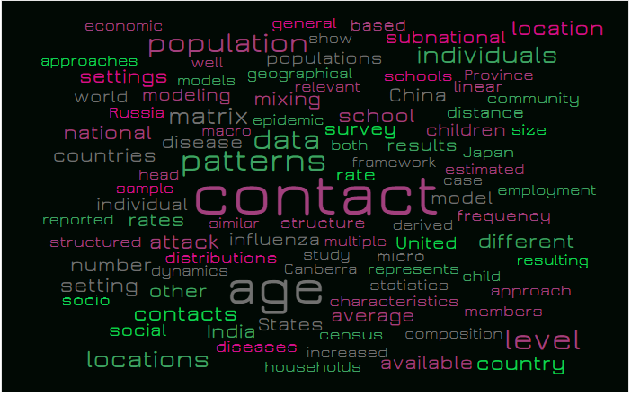

Contact structure patterns multiple data study both rate Canberra influenza epidemic mixing age similar survey framework derived distributions relevant micro school characteristics represents disease attack statistics matrix results geographical State saverage populations population modeling model China children census increased show United schools models case house holds India individuals estimated available contacts individual general diseases dynamics rates subnational other distance frequency head locations based countries different child composition sample settings linear Japan social number national setting members Russia approach resulting approaches well reported macrolevel structured country employment economic world Province size community socio location

**- Trabalhos recentes efetuados na UPM**

FERRAZ, D. F.; MONTEIRO, L. H. A. The impact of imported cases on the persistence of contagious diseases. Ecological Complexity, v. 40, p. 100788, 2019.

Resultado:

MONTEIRO, L. H. A.; CHIMARA, H. D. B.; BERLINCK, JG Chaui. Big cities: shelters for contagious diseases. Ecological Modelling, v. 197, n. 1-2, p. 258-262, 2006.

MONTEIRO, L. H. A. Sistemas Dinâmicos Complexos. 2ª. Edição. Editora Livraria da Física, 2014.

MORAES, A. L. S.; MONTEIRO, L. H. A. On considering the influence of recovered individuals in disease propagations. Communications in Nonlinear Science and Numerical Simulation, v. 34, p. 224-230, 2016.

SCHIMIT, P. H. T.; MONTEIRO, L. H. A. A vaccination game based on public health actions and personal decisions. Ecological Modelling, v. 222, n. 9, p. 1651-1655, 2011.

1. Será incluído na análise o seguinte texto recém publicado:

MONTEIRO, L. H. A. An epidemiological model for SARS-CoV-2. Ecological Complexity, p. 100836, 2020.

1. **Metodologia para a formalização das classes, subclasses, membros e propriedades**

**4.1 Contagem de palavras**

Um software para contagem de palavras 2 será utilizado para verificar as palavras mais utilizadas em todos os textos compactados no arquivo <Input_wordcounternet.txt> e posteriormente essas palavras serão pesquisadas no texto básico e se transformarão em classes e as relações serão efetuadas manualmente via análise das classes e subclasses.

Serão utilizados os seguintes **limites máximos** como característica da Ontologia:

**52** classes e subclasses,

**33** propriedades para cada classe/subclasse 3.

* 1. **Ferramenta 5W4H**

Será aplicada a ferramenta **5W4H** para cada elemento elencado pelo software, usando a seguinte transformação:

– WHAT -> o quê – “Classes, subclasses e membros” (Objeto)

– WHY -> Por quê – “Propriedades” (Justificativa)

– HOW -> Como fazer - “Propriedades” (Estratégia)

– WHEN -> Quando - “Propriedades” (Unidade temporal)

– WHERE -> Onde - “Propriedades” (Localização Geográfica)

– HOW FEEL -> Para quê - “Propriedades” (Resultados esperados)

– WHO -> Para quem - “Classes, subclasses e membros” (Público Alvo)

– HOW MUCH -> Quanto - “Propriedades” (Unidade de valor)

– HOW MEASURE -> Como medir - “Propriedades” (Monitoramento, controle, parametrizações)

2. Word Counter (wordcounter.net)

3. número passível de modificação, conforme o desenvolvimento da tarefa.

* 1. **Exemplos**

Exemplos gerais do 5W4H:

1. (WHAT) Coronavirus disease 2019 (COVID-19) - is a - Severe acute respiratory infection **[Subclasses]**
2. (HOW) Coronavirus disease 2019 (COVID-19) – was caused by - severe acute respiratory syndrome coronavirus 2 (SARS-CoV-2) **[proprieties]**
3. (WHERE) Coronavirus disease 2019 (COVID-19) – was started - in Wuhan City, Hubei Province, China **[proprieties]**
4. (WHEN) Coronavirus disease 2019 (COVID-19) – was started - in December 2019 **[proprieties]**
5. (WHAT) Middle East respiratory syndrome (MERS) – is a - Respiratory infection **[Subclasses]**
6. HOW MUCH) - Respiratory infection – has as a cause – a mild common cold-like illness **[proprieties]**
7. (HOW MUCH) - Respiratory infection – has as a cause - a severe viral pneumonia that is potentially fatal **[proprieties]**
8. (WHO) SARS-CoV-2 - is the name of - the virus owing to the virus's genetic similarity to the SARS-CoV vírus disease spectrum **[proprieties]**
9. (HOW MEASURE) Disease spectrum - is diferent than - SARS-CoV vírus disease **[Subclasses disjuntas]**
10. (HOW MEASURE) Disease transmission – is diferent than - SARS-CoV vírus disease **[Subclasses disjuntas]**

**Utilização do Prótegé**

1. **Criação de Classes, Subclasses, Propriedades, Subpropriedades, membros e anotações no Software Protégé.**

**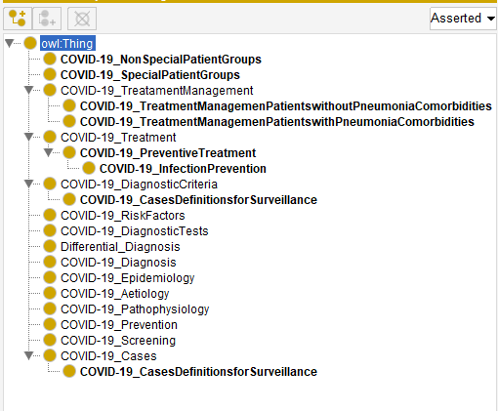**

1. **Execução de testes iniciais (somente com algumas classes).**

**